BSC-3 – Controls – FRS
  - Replacement of BSC for mix vent and cow cooling

Contents
2 Introduction 4
3 I/O 4
4 IO-boards 4
4.1.2 Selection types 4
5 Weather station 5
5.1 Controls 5
5.1.1 Outside temperature 6
5.1.2 Windspeed 6
5.1.3 Backbone 6
5.1.4 Prepare for the future 7
5.2 Options 7
5.3 Setpoints 9
5.4 Main group 9
5.5 Diagnosis 9
5.6 Alarms 9
6 Climate control 10
6.1 Controls 10
6.1.1 Temperature 10
6.1.2 Relative humidity 11
6.1.3 Temperature Humidity Index 13
6.1.4 Minimum and maximum values 14
6.2 Options 14
6.3 Setpoints 15
6.4 Main group 16
6.5 Diagnosis 16
6.6 Alarms 17
7 Spray control 18
7.1.1 Hardware 18
7.2 Controls 19
7.2.1 Areas and zones 19
7.2.2 Spray control 19
7.2.3 Safety temperature 20
7.2.4 Average night temperature 21
7.2.5 Timeslots 21
7.2.6 Maximum humidity 21
7.2.7 Maximum windspeed 21
7.2.8 Cow presence 21
7.2.9 Override function 22
7.2.10 Operation mode 22
7.2.11 Valve control 23
7.3 Options 26
7.4 Setpoints 29
7.5 Main group 32
7.6 Diagnosis 33
7.7 Alarms 33
8 Circulation fans 33
8.1.1 Hardware 33
8.2 Controls 34
8.2.1 Areas and groups 34
8.2.2 Circulation control 35
8.2.3 Timeslots 36
8.2.4 Maximum windspeed 37
8.2.5 Override function 37
8.2.6 Operation mode 38
8.2.7 Outputs per group 38
8.2.8 Connected to spraying 38
8.3 Options 39
8.4 Setpoints 43
8.5 Main group 46
8.6 Diagnosis 47
8.7 Alarms 47
9 Questions 47

Introduction
With this document we want to determine the FRS (functional requirement specifications) for the controls of the new BSC controller. In this document we will further specify how we are going to implement the functionality mentioned in the CRS document. Besides this document there is also a Viso-file with flowcharts of the installation menu and an overview of the screens.
For readers from DeLaval a few remarks have to be made:
- Basically this document will also serve as input for the Hotraco development team, therefore we sometimes refer to other Hotraco products or documents. This is mainly done to explain our developers why we made some choices or can find additional information. To prevent confusion this is done in italic so you know you can skip these parts.
- The development of the BSC3 is based on the Halo platform. To keep this document summarily we leave out all platform functionality. We only describe the screens and controls that are specific for the new BSC controller.
We start with a chapter with some remarks about IO. Thereafter there is a chapter per control. These control chapters will be structured as follows:
- Controls:
In this paragraph the working of the according control is explained.
- Options:
This paragraph the sections and items of the of the option screen (installation menu) are stated. The headers of the Sections and Items are marked with a different font. The sections correspond with the headers on the screen, the items with the individual settings. Per item is stated when the item is visible, how the item is represented, what can be adjusted, who has the right to adjust, what the input range is and the default value. The text in the headers is the name of the section or item and will also be used on the controller.
- Settings:
In this paragraph the sections and items of the settings screen (user setpoints) are stated. The way this is paragraph is structured is equal to the option screen.
- Main group:
This paragraph states which items should be visible in the main group
- Diagnosis:
This paragraph states which items should be visible in the diagnosis screen. To make sure the user can do a failure analysis without entering the installation menu we show at least the actual value and the assignments of all IO connected.
- Alarms:
In the alarm paragraph all alarms for the according control are stated. There is described when the alarms should occur, how the alarm can be resolved and whether the alarm can be suppressed or reset.
When we refer to specific options or settings we use ‘brackets’ and leave out the article.
Unless otherwise stated, the order of the elements in this document is leading.

I/O
In the I/O option screen the installer can set which IO-boards are connected and how the IO’s are used. The I/O option should be according to Hotraco standards. However a few remarks have to be made to explain how the I/O option screen should be customized to fit the BSC functionality.

IO-boards
In the I/O option screen the following boards should be available:
- IO-12-17P
Since the BSC software doesn’t use the RS485/Modbus interface we should hide the according settings.
- IO-08-11P
Since the IO-08-11P was the default IO-board for the BSC2 the BSC3 should also be able to support this board. It has 4 analog inputs, 4 digital inputs (level and counter), 2 analog output, 8 digital outputs and an alarm contact. Regarding to the analog inputs we must be aware that input 1 and 2 are for temperature measurement only. And that input 3 and 4 only support 0-10V and 0-20mA measurements (based on jumper setting).
- IO-06-14:
No remarks:
- IO-12-06:
Since cow don’t lay eggs we should hide the egg counter settings.

Default IO board
The default IO board for the BSC3 is the CAN-IO-12-17P therefore IO-12-17P[1] must be activated by default.

Selection types

Analog inputs
For the analog inputs the following selection types must be available:
- Temperature:
When temperature is selected the actual temperature in °C is shown. Besides the description no further settings are needed, except for temperature measurement on the IO-08-11P. Since the temperature circuit on this board is done with 2-wire sensors temperature inputs on this board should have the possibility to adjust an offset to compensate for the wirelength.
- Humidity:
When humidity is selected the actual RH is shown in % and with an accuracy of 1%. Our RH sensor gives a 0-5V signal, therefore the default scaling for humidity inputs is:
Minimum: 0 % = 0.00V
Maximum: 100 % = 5.00V
For the future we should also support current measurement, this means we should be able to select the signal type. Like we can select 0..5V and 0..20mA for CO₂-sensors. Since RH is always between 0 and 100% these percentages should be fixed.
- Windspeed:
When windspeed is selected the actual windspeed in m/s and with an accuracy of decimal. The windspeed is normally measured with an anemometer that gives 5V at 30m/s, therefore the default scaling for windspeed inputs is:
Minimum: 0.0 m/s = 0.00V
Maximum: 30.0 m/s = 5.00V

Digital inputs
For the digital inputs the following selection types must be available:
- Circulation fans:
For the button
- Spraying:
For the button and for cow detection sensors.
Both the circulation and spraying inputs have level function so no further settings are needed.

Analog outputs
For the analog outputs the following selection types must be available:
- Circulation fans:
When this type is selected the analog output is scaled a 0-10V output e.g.:
Minimum: 0% = 0.0V
Maximum: 100% = 10.0V
Since SFS and MFS don’t support switching off based on the analog signal and we hide the setting for the OFF-voltage.

Digital outputs
For the digital outputs the following selection types must be available:
- Circulation fans:
- Spraying:
Both the circulation and spraying outputs are standard digital outputs so besides the description no further settings are needed.
The first 8 digital outputs of the CAN-IO-12-17 are solid state outputs that support only 24Vdc. DeLaval uses 24Vac solenoids for the spraying valves. Auxiliary relays are needed to connected the valves to these outputs. Since DeLaval normally uses the RK-4 relay box there is no need to prevent the solid state outputs are used for the valves.

Weather station

Controls
The weather station is responsible for gathering weather data like:
- Outside temperature
- Outside humidity
- Windspeed
- Wind direction
- Rain/precipitation
For the current development we only need outside temperature and windspeed, but this could expand in future. The installer can select per item whether the according value is activated and how the value should be determined. There are 2 options: the value is measured by an analog input or received from another controller on the ethernet backbone.

Outside temperature
The outside temperature can be measured via an analog input that supports temperature measurement. Our temperature circuits have a measuring range from -50.0 to 102.0 °C, therefore the measured value should always be within this range. In case the received value is below -50.0 or above 102.0 °C the controller should see the sensor as defective and give the alarm ‘Weather station; Outside temperature sensor defect’.
Although the outside temperature isn’t necessary for the controls Delaval want to have this value available, so they can relate the conditions in the barn to the outside condition when they are using data.

Windspeed
The windspeed can be measured by an anemometer that’s connected to an analog input that supports voltage measurement. The Hotraco windspeed sensor is an anemometer that give an 0..5V signal that corresponds with 0.0 to 30.0 m/s, therefore we cannot detect a defective sensor.

Average windspeed
The windspeed often varies a lot, therefore the controls don’t use the actual windspeed, but use a value that’s averaged over a longer period, for example 15 minutes. The period over which the averaging is done is adjustable.
- Actual value:
The actual value as measured or received via the backbone. This value should be visible in the diagnosis screen.
- Display value:
The windspeed averaged over a period of 10 seconds. This value is used to display in the main group.
- Control value:
The windspeed averaged over a long period according to the ‘Time average’ setting. This value is used by the controls.
For the algorithm for averaging over a short and along period we refer to the existing Fortica software. For testing purposes its important that the actual value can be use for the controls by setting ‘Time average’ to 0.

Backbone
When Hotraco controllers are connected to the same network they can exchange data. At Hotraco ‘backbone communication’ means the communication between controllers on the same ethernet network. This backbone communication can be used exchange data like weather parameters between controllers at the same location. Per item can be selected whether it used and if the value should be measured by an ‘Analog input’ or received via the ‘Backbone’.

Receive from backbone
When the option ‘Backbone’ is activated at an item of the weather station, the controllers expects to receive a broadcast message with the according value from one of the other controllers on the network. Normally this value is received every 10 seconds. If there is no value received for more than 25 seconds the controller should give an alarm to warn the user that the according value is no longer available.

Transmit via backbone
When the option ‘Transmit’ is activated at an item of the weather station, the controller should transmit the according value every 10 seconds. The way and extent to which averaging has to be done can depend on the application. Therefore we always send the raw value, before averaging, when weather parameters are exchanged.
Please note: In the current implementation of the weather communication we has a shortcoming. We don’t can see whether a received value is valid or not. Instead of sending a message that there is no valid value the sender simply stops sending. This could lead to the conclusion that something is wrong with the communication, while there is actually a problem with the sensor.

Prepare for the future
Although the weather station now only contains outside temperature and windspeed we should take into account the possibility that other items (like wind direction or rain detection) are added in future. In that case the digital weather station WSC11 (that we already use on the Orion-GC) could be a good alternative for the current analog sensors.
The design of this option screen differs slightly from the weather station options on other Hotraco controllers. In the past per item we had one option with four choices (none, connected, connected + transmit, receive), that determined whether the value should be available, how it is determined and whether it should be transmitted. Now we split this in 3 options to prevent that the number of choices explodes when we would add the digital weather station in future.
See also the snowball documentation on this topic.

Options
In the option screen of weather station we find the following options:

Weather station
In this section we find the following options:
Weather station
This option is available in case the module ‘CowCooling’ is activated. Here the installer can set with a checkbox whether weather parameters like the outside temperature and windspeed should be determined and available for other controls.

Outside temperature
In this section we find the following options:
Outside temperature
This option is available in case the option ‘Weather station’ is activated. Here the installer can set with a checkmark whether the outside temperature should be determined and be available for the controls.
Type
This option is available in case the option ‘Outside temperature’ is activated. Here the installer can set how the outside temperature is determined. There are 2 options:
- Backbone
The outside temperature is received via the backbone.
- Analog input:
The outside temperature is measured a sensor connected to an analog input.
Analog input
This option is available in case the option ‘Outside temperature’ is activated and the type ‘Analog input’ is selected. Here the installer can assign the analog input for the outside temperature sensor.
Transmit
This option is available in case the option ‘Outside temperature’ is activated and the value isn’t received via the backbone. Here the installer can set with a checkbox whether the outside temperature should be send to other controllers via the backbone.

Windspeed
In this section we find the following options:
Windspeed
This option is available in case the option ‘Weather station’ is activated. Here the installer can set with a checkmark whether the windspeed should be determined and be available for the controls.
Type
This option is available in case the option ‘Windspeed’ is activated. Here the installer can set how the outside temperature is determined. There are 2 options:
- Backbone
The windspeed is received via the backbone.
- Analog input:
The windspeed is measured a sensor connected to an analog input.
Analog input
This option is available in case the option ‘Windspeed’ is activated and the type ‘Analog input’ is selected. Here the installer can assign the analog input for the windspeed sensor.
Transmit
This option is available in case the option ‘Windspeed’ is activated and the value isn’t received via the backbone. Here the installer can set with a checkbox whether the windspeed should be send to other controllers via the backbone.

Setpoints
The weather station has following settings.

Outside temperature
Out of use
This setting is available in case the option ‘Outside temperature’ is activated. Here the user can set the outside temperature assign the analog input for the windspeed sensor.

Windspeed
Out of use
This setting is available in case the option ‘Windspeed’ is activated and the type ‘Analog input’ is selected. Here the installer can assign the analog input for the windspeed sensor.
Time average
This setting is available in case the option ‘Windspeed’ is activated. Here the user can set over which period the windspeed should be averaged. This value can be set from 0 to 60 minutes and has a default of 15 minutes.

Main group
The main group or of the weather station shows the following items:
- The actual outside temperature
- The actual windspeed

Diagnosis
The diagnosis screen of weather station shows the following values:
In case the option outside temperature is activated:
- The actual value and the IO-assignment of the outside temperature or the actual value and the backbone connection status.
- The min/max values of the outside temperature
In case the option wind speed is activated:
- The actual value and the IO-assignment windspeed
- The min/max values of the windspeed
- The average windspeed

Alarms
The weather station has the following alarms:
Weather station; Outside temperature sensor defect
In case the option ‘Outside temperature’ is activated and the source ‘Analog input’ is selected, the controller should get valid temperatures form the input. In case the input value is below -50.0 or above 102.0 °C and the outside temperature is not set out of use the controller gives the alarm ‘Weather station; Outside temperature sensor defect’. The alarm is automatically reset when a valid value is received. This is a hard alarm that can be suppressed but cannot be reset by the user.
Weather station; no outside temperature received
In case the option ‘Outside temperature’ is activated and the source ‘Backbone’ is selected, the controller should receive the actual outside temperature periodically. If there is no outside temperature received during 25 seconds and the outside temperature is not set out of use the controller gives the alarm ‘Weather station; no outside temperature received’. The alarm automatically reset when a new value is received. This is a soft alarm that can be suppressed but cannot be reset by the user.
Weather station; no windspeed received
In case the option ‘Windspeed’ is activated and the source ‘Backbone’ is selected, the controller should receive the actual windspeed periodically. If there is no windspeed received during 25 seconds and the windspeed is not set out of use the controller gives the alarm ‘Weather station; no windspeed received’. The alarm automatically reset when a new value is received. This is a soft alarm that can be suppressed but cannot be reset by the user.

Climate control

Controls
Climate control is responsible for measuring and checking temperature humidity and THI. When there are sensors per area, the average temperature and/or THI serve as a backup value in case an area has no valid sensor left. Therefore it’s recommended to assign the sensors of the areas also at climate control.
There is a fundamental difference between the climate in dairy barns and houses for poultry and pigs. Dairy barns are quite open and not isolated, therefore the climate is very dependent on the weather. If its cold outside, it will also be cold inside the barn, and if its hot outside, it will also be hot inside the barn. Unlike cooling in poultry and pig house, avoiding heat stress for dairy is not about cooling the air in the barn. Its about helping the cows to get rid of excessive heat. This can be achieved in 2 ways: by creating extra airflow (using the wind chill effect) or by making the cows wet (using the evaporating water to extract heat directly from the cows).
Since we use cooling mechanisms that work directly on the cows, the heat stress the cow expire is not directly related to the measured temperature and/or THI. Therefore There is no set value for temperature or THI that we try to maintain, and therefore the minimum and maximum alarms are also less important.

Temperature
Without temperature no climate controls, therefore temperature measurement is automatically activated when climate control is activated. Climate control is responsible for measuring the room temperature. In the installation menu the installer can assign one or more analog inputs to measure the room temperature. When there is more than one sensor assigned the room temperature is based on the average of the measured values.

Temperature measurement
Temperature sensors can have 3 states:
- Defective:
Our temperature circuits have a measuring range from -50.0 to 102.0 °C, therefore the measured value should always be within this range. In case the received value is below -500 or above 1020 the controller sees the sensor as defective.
- Out of use:
Sometime the measured value of a sensor is unreliable. By setting the according sensor out of use the user can avoid that the sensor keeps disturbing the controls or keeps generating alarms.
- Valid:
When the measured value is within the normal range and the sensor isn’t out of use we see the measured value of the according sensor as valid.
The room temperature is determined based on the average measuring value of valid sensors. When there is no sensor assigned or there is no valid sensor left, the controller should give the alarm ‘No valid room temperature’. When there is no valid room temperature the actual room temperature stays on the last value.
In case a sensor is defective and the sensor is not out of use the controller should give the alarm ‘Room temperature sensor x defective’.

Temperature alarms
In case the option temperature alarms is activated the controller checks whether the average temperature is within the set alarm limits. Unlike other controllers the BSC has no general set temperature, the therefore the alarm limits are set as absolute values.
When the temperature is below ‘Minimum alarm’ the controller should give a ‘Minimum temperature alarm’. When the temperature is above ‘Maximum alarm’ the controller should give a ‘Maximum temperature alarm’. These alarms work directly on the actual value, without delay or hysteresis.
On BSC2 the temperature alarms were related to set temperature of cow cooling, regardless whether that setpoint was available. For example if cow cooling was controlled on THI, the temperature setpoint was used while it wasn’t visible.

Relative humidity
Besides the temperature humidity also has an influence on the extent to which cow are experiencing heat stress. The humidity can be measured with RH sensors. These sensors measure the relative humidity. By definition RH is the amount of water in the air divided by the maximum amount of water the air can contain at the specific temperature and pressure. This is expressed as a value from 0 to 100%.

RH measurement
Our standard RV-A sensor has an output signal of 0..5V, which corresponds with a RH of 0..100%. In the past this corresponded exactly with the 0..5V input range of our IO-board. Nowadays we often have 0..10V inputs this means the measured value could exceed the 100%. The measured value could also become negative, for example when we use a sensor with 4..20mA, (which is converted to 1..5V), 0mA would correspond with -25%.
On our CAN-protocol we support 2 types of analog values: limited and unlimited. The limited variant truncate the return value to minimum and maximum value, the unlimited does not. To avoid values below 0% or above 100%, we would like to limit the values but to detect defective sensors we need to know whether the value is outside these limits. In fact we want the best of 2 worlds:
- We don’t want to show values below 0% or above 100%, therefore the shown value should be truncated at 0 and 100%.
- We want to be able to detect defective sensors to give an alarm when the measured value is outside the normal range of 0 and 100%.
When de measured value is outside the normal range the controller should give a ‘RH sensor x defective’ alarm. Since 0 and 100% are valid values that could correctly appear, and there also could be a slight measuring error, we must obtain a safety margin for the sensor defective alarm. Therefore we take 10% margin so values below -10% or above 110% should lead to a sensor defect alarm.

Average RH measurement
Just like for temperature measurement 1 or more RH sensors can be assigned. These sensors can also have 3 states:
- Defective:
When the measured value is more than 10% outside the range the controller should see the sensor as defective. Our humidity sensor normally has an output range from 0..5V, so when the measured value is above 5.5V the sensor is seen as defective. When a 4..20mA sensor is applied the value is seen as defective in case the measured current is below 3.6mA or above 20.4mA.
- Out of use:
Sometime the measured value of a sensor is unreliable. By setting the according sensor out of use the user can avoid that the sensor keeps disturbing the controls or keeps generating alarms.
- Valid:
When the measured value is within the normal range and the sensor isn’t out of use we see the measured value of the according sensor as valid.
The relative humidity is determined based on the average measuring value of valid sensors. When there is no sensor assigned or there is no valid sensor left, the controller should give the alarm ‘No valid RH. When there is no valid RH the actual RH stays on the last value.
In case a sensor is defective and the sensor is not out of use the controller should give the alarm ‘RH sensor x defective’.

RH alarms
When the option ‘RH alarms’ is enabled the user can set the limits for the minimum and maximum RH alarm. Since there is no general RH setpoint the alarm limits are not related to a set value, but set as absolute values.
When the RH is below ‘Minimum alarm’ the controller should give a ‘Minimum RH alarm’. When the RH is above ‘Maximum alarm’ the controller should give a ‘Maximum RH alarm’. These alarms work directly on the actual value, without delay or hysteresis.

Temperature Humidity Index
The ‘Temperature Humidity Index’ (abbreviated THI) is a value that combines temperature and humidity to one value that indicates the extent to which cows experience heat stress. Unlike on our poultry controllers the THI is not simply an addition of temperature and humidity. THI is calculated according to the following formula:
$$THI=0.81×C+RH\%×\left(C-14.4\right)+46.4$$
In which C is the temperature in °C and RH% is the relative humidity in %. The THI has no unit and is displayed with an accuracy of 1.
The THI can only be calculated if there is a valid temperature and a valid humidity. If this is not the case the controller should give the alarm ‘No valid THI’. In theory the measured THI can vary from 6 (0% RH @ -50.0°C ) to 217 (100% RH @ 102.0°C )

Accuracy
On the BSC2 the THI was displayed with an accuracy of 0.1, this was mainly based on some settings that were used in the temperature and THI domain. Since the humidity measurement has only an accuracy of 1% it makes no sense to display the THI with an accuracy 0.1. To explain this we look what’s happening when the least significant bit of the RH is flipping. For example when RH is switching between 60 and 61%. At 30.0 °C the change of 1% RH leads to an change of approximately 0.3 THI.

THI alarms
When the option ‘THI alarms’ is enabled the user can set the limits for the minimum and maximum THI alarm. Since there is no general THI setpoint the alarm limits are not related to a set value, but set as absolute values.
When the THI is below ‘Minimum alarm’ the controller should give a ‘Minimum THI alarm’. When the THI is above ‘Maximum alarm’ the controller should give a ‘Maximum THI alarm’. These alarms work directly on the actual value, without delay or hysteresis.

Average THI
For THI controls the THI value can be averaged over a longer period. With ‘Time average’ the user can set over how many hours the THI should be averaged. This period can be set from 0 to 24 h. The actual THI is sampled every second. Per 15 minutes the sum and the number of samples is determined. A maximum of 96 combinations of sums and number of samples can be stored in a buffer. The ‘Time average’ settings determines over how many quarters the average should be determined. To prevent strange effects when the buffer isn’t completely filled, the average is determine by dividing the sum of the sums per quarter by the sum of the numbers per quarter.
When ‘Time average’ is set to 0 the averaged THI is equal to the actual THI, this is important for testing purposes. The values in the buffer should be stored regardless ‘Time average’, so the average doesn’t change after changing ‘Time average’ back and forth.
Since it is likely that the averaging is done over a longer period the data used to determine the average should be saved and restored at a restart.

Minimum and maximum values
For diagnosis the controller should store the minimum and maximum values of the individual sensors and the average temperature, RH and THI. These values should be determined over the last 23 full hours and the current hour. Both the values and the times at which the values occurred should be stored.
In case a sensor is defective the actual is not representative and the normal range, therefore it shouldn’t be stored as min or max value. In case a sensor is out of use the actual value should still be measured and the minimum and maximum value should still be stored.
See also the Snowball documentation on this topic.

Options
In the option screen of climate control we find the following sections and settings:

Climate control
In this section we find the following options.
Climate control
This option is available in case the module ‘CowCooling’ is activated. Here the installer can set with a checkbox whether climate controls are used.
For now this might seem a bit odd since the only available controls are climate controls, but when we would add extra controls (like manure or lighting) its better to have a separate option for climate controls.
Temperature sensors
This option is available in case the option ‘Climate control’ is activated. Here the installer can assign up to 8 temperature sensors. At least 1 sensor should be assigned.
Temperature alarms
This option is available in case the option ‘Climate control’ is activated. Here the installer can set with a checkmark whether the user should be able to use the minimum and maximum temperature alarm.

Humidity
In this section the installer can set options regarding to humidity measurements and alarms.
RH measurement
This option is available in case the option ‘Climate control’ is activated. Here the installer can set with a checkmark whether the RH (relative humidity) should be measured.
RH sensors
This option is available in case the option ‘RH measurement’ is activated. Here the installer can assign up to 4 RH sensors. At least 1 sensor should be assigned.
RH alarms
This option is available in case the option ‘RH measurement’ is activated. Here the installer can set with a checkmark whether the user should be able to use the minimum and maximum RH alarm.

Temperature Humidity Index
In this section the installer can set options regarding to the THI. The THI is a value based on the measured temperature and humidity that represents the degree of heat stress for the animals.
THI measurement
This option is available in case the option ‘RH measurement’ is activated. Here the installer can set with a checkmark whether the THI should be determined.
THI alarms
This option is available in case the option ‘THI measurement’ is activated. Here the installer can set with a checkmark whether the user should be able to use the minimum and maximum THI alarm.

Setpoints
In the setpoint screen of climate control we find the following sections and settings:

Room temperature
Minimum alarm
This setpoint is available in case the option ‘Temperature alarms’ is activated. Here the user can set below which temperature the controller should give a minimum alarm. This value can be set from -50.0 to 50.0 °C and has a default value of 0.0 °C.
Maximum alarm
This setpoint is available in case the option ‘Temperature alarms’ is activated. Here the user can set above which temperature the controller should give a maximum alarm. This value can be set from -50.0 to 50.0 °C and has a default value of 35.0 °C.
Sensors out of use
This setpoint is available in case the option ‘Climate control’ is activated. Here the user can set with al list of checkboxes whether the respective sensor is in or out of use. By default all sensors are in use.

Humidity
Minimum alarm
This setpoint is available in case the option ‘RH alarms’ is activated. Here the user can set below which RH the controller should give a minimum alarm. This value can be set from 0 to 100 % and has a default value of 0%.
Maximum alarm
This setpoint is available in case the option ‘RH alarms’ is activated. Here the user can set above which RH the controller should give a maximum alarm. This value can be set from 0 to 100 % and has a default value of 100%.
Sensors out of use
This setpoint is available in case the option ‘RH measurement’ is activated. Here the user can set with al list of checkboxes whether the respective sensor is in or out of use. By default all sensors are in use.

THI alarms
Minimum alarm
This setpoint is available in case the option ‘THI alarms’ is activated. Here the user can set below which temperature the controller should give a minimum alarm. This value can be set from 0 to 120 and has a default value of 32.
Maximum alarm
This setpoint is available in case the option ‘THI alarms’ is activated. Here the user can set above which temperature the controller should give a maximum alarm. This value can be set from 0 to 120 and has a default value of 100.

Average THI
Time average
This setpoint is available in case the spraying valves are controlled based on THI. Here the user can set over which time the average THI should determined. This value can be set from 0 to 24h and has a default value of 0h.

Main group
The main group screen of climate control shows the following values:
- The average temperature
- The average humidity
- The actual THI
- The averaged THI
- Below the main item we see an icon bar that indicates it when something isn’t functioning normal.
  - Sensors out of use
  - Sensors defect
- A bar chart that shows the actual value of the average value and the value per sensor.

Diagnosis
The diagnosis screen of climate control shows the following values:
In case there is more than 1 temperature sensor assigned:
- The average temperature
- The min/max values of the average temperature
In case there are temperature sensors assigned:
- The actual value and the IO-assignment of all assigned temperature sensors
- The min/max values of the assigned temperature sensors
In case there is more than 1 humidity sensor assigned:
- The average RH
- The min/max values of the average RH
In case there are humidity sensors assigned:
- The actual value and the IO-assignment of all assigned RH sensors
- The min/max values of the assigned RH sensors
In case the option THI is activated:
- The actual THI
- The averaged THI

Alarms
Room temperature; sensor x defect
For every assigned temperature sensor the controller should c
In case the actual value of a temperature sensor is below -50.0 or above 102.0 °C and the sensor is not out of use the controller should give the alarm ‘Room temperature; Sensor x defect’. In case a description is set, ‘Sensor x’ is replaced by the description, in case no description is set, the x is replaced by the number of the IO assignment. This alarm is a hard alarm that can be suppressed, resetting isn’t possible.
No valid room temperature
In case there is no temperature sensor assigned or all sensors are out of use or defect the controller should give the alarm ‘No valid room temperature’. This alarm is a hard alarm that can be suppressed, resetting isn’t possible.
Minimum room temperature
In case the option ‘Temperature alarms’ is activated and the average temperature is below the set ‘Minimum alarm’ the controller should give the alarm ‘Minimum room temperature’. This alarm is a hard alarm that can be suppressed, resetting isn’t possible.
Maximum room temperature
In case the option ‘Temperature alarms’ is activated and the average temperature is above the set ‘Maximum alarm’ the controller should give the alarm ‘Maximum room temperature’. This alarm is a hard alarm that can be suppressed, resetting isn’t possible.
RH; sensor x defect
In case the actual value of a RH sensor is below -10 or above 110 % and the sensor is not out of use the controller should give the alarm ‘RH temperature; Sensor x defect’. In case a description is set, ‘Sensor x’ is replaced by the description, in case no description is set, the x is replaced by the number of the IO assignment. This alarm is a hard alarm that can be suppressed, resetting isn’t possible.
No valid ‘RH
In case there is no humidity sensor assigned or all sensors are out of use or defect the controller should give the alarm ‘No valid RH’. This alarm is a hard alarm that can be suppressed, resetting isn’t possible.
Minimum RH
In case the option ‘RH alarms’ is activated and the average RH is below the set ‘Minimum alarm’ the controller should give the alarm ‘Minimum RH’. This alarm is a hard alarm that can be suppressed, resetting isn’t possible.
Maximum RH
In case the option ‘RH alarms’ is activated and the average RH is above the set ‘Maximum alarm’ the controller should give the alarm ‘Maximum RH’. This alarm is a hard alarm that can be suppressed, resetting isn’t possible.
Minimum THI
In case the option ‘THI alarms’ is activated and the actual THI is below the set ‘Minimum alarm’ the controller should give the alarm ‘Minimum THI’. This alarm is a hard alarm that can be suppressed, resetting isn’t possible.
Maximum THI
In case the option ‘THI alarms’ is activated and the actual THI is above the set ‘Maximum alarm’ the controller should give the alarm ‘Maximum THI’. This alarm is a hard alarm that can be suppressed, resetting isn’t possible.
Please note: Since we already ‘No valid alarms’ for temperature and RH a ‘No valid THI’ alarm isn’t needed.

Spray control
Basically spray control exist of a number of sprayers that can be used to spray water over the cows. The sprayers are controlled by one or more water valves. The sprayers operate at normal water pressure. The aim of the spraying is to make the back of the animals wet so the evaporating of the water cools the animals directly. The water that falls past the cows will drip trough the slats into the manure pit. This is unlike cooling systems we know from poultry and pigs, where we want to lower the room temperature without making the animals or the manure wet.
Besides the sprayers there are also circulation fans, these fans are used to create a cooling airflow over the animals. During spraying the fans could blow the water to the wrong spot, for example in the cubicles or on the feed. To prevent this the fans can be connected to the spraying so circulation control can reduce the speed of the fans or switch the fans off during spraying.

Hardware
From a hardware perspective the spraying is quite simple. The valves require 24 Vac to open, this can easily be controlled by digital outputs. Because of the alternating current dry contacts are needed. This means that we need to use auxiliary relays in case we want to use the solid state outputs (digital output 1 to 8) of the IO-12-17.
For the cow presence detection, light beam sensors are used. These sensors exist of an transmitter and receiver, (for example the O4E500 / O4ES500 of IFM). The light beam sensors can cover a range up to 80 meter. Both the transmitter and the receiver need a 24Vdc power supply. The receiver has a NPN output that can be connected to a digital input. The polarity of the sensor is adjustable by a push button. For BSC we the input to be on when cows are detected.

Controls
Spray control is build up from a number of functions of which some are optional and some are always active. In this chapter we will discuss all these functions separately. The figure below schematically shows how these different functions interact.
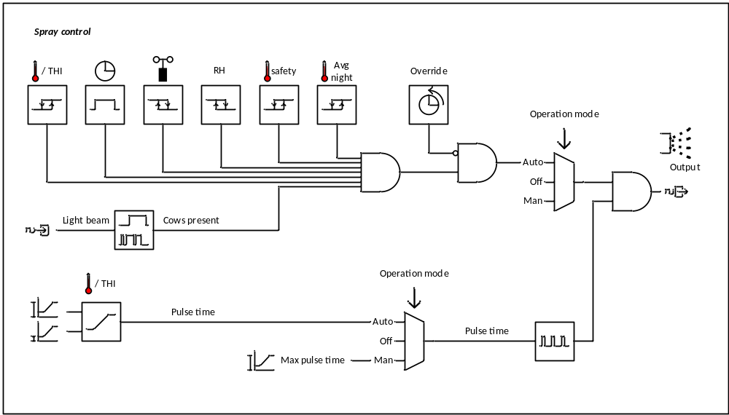
Figure 1: Schematic overview of spray control

Areas and zones
For the spraying we can have a maximum of 8 areas with up to 4 zones per area. The areas are used when spraying in separate parts of a barn require different settings and/or different temperature/RH sensors.
Different settings can be necessary in case different time slots are needed or there are different types of animals (for example production cows, dry cows, or replacement animals). Different sensor can be necessary in case the construction of the barn differs or in case the stocking density or productivity of the animals differs.
Zones can be used in combination with cow presence detection. All zones of an area work according the same settings and the same sensors, except for the cow presence detection.

Spray control
Basically the spraying valves are controlled based on the difference between the measured value and the set value. This can be based on temperature or on THI. The spraying gets active when the measured value is equal to or higher than the set value and gets inactive when the measured value is lower than the set value minus the hysteresis. In addition to this main control there can be extra conditions like timeslots and safety temperature that determine whether the spraying should be active. In case there is no valid measured value available the spraying stays off.
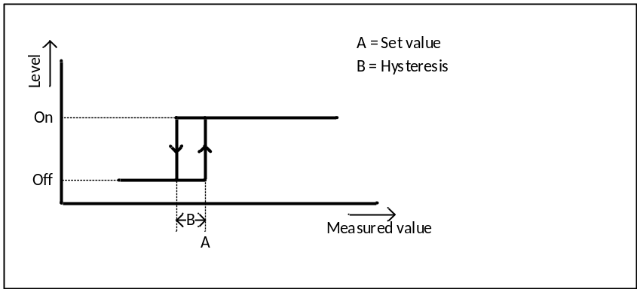
Figure 2: Main spray control based on temperature or THI

Per area
The main control based on temperature or THI is evaluated per area. In case the option ‘Set value per area’ is activated, there is a separate set value for every area. Normally this control works on the actual temperature or THI determined by climate control but in case the option sensors per area is activated the actual temperature or THI are determined per area. In case a sensor is defective or set out of use at climate control it should also not be used to determine the measured value of an area. In case there are no valid sensors left for an area, the actual temperature or THI determined by climate control is used instead.

Safety temperature
When the spraying is controlled based on the THI an additional safety temperature and hysteresis can be set. Spraying stops when the temperature is below the set safety temperature, to prevent excessive switching the spraying starts only when the temperature is above the safety temperature plus hysteresis.
The reason to have this safety temperature is that THI control is based on the average THI. When the temperature suddenly drops, the average THI could stay high for a while, which could cause the spraying to stay on while it’s to cold.
N.B.: On the BSC2 this function was know as night set temperature and only applied to the night period. Since temperature drops can also occur during the day, for example by a thunderstorm, we removed the dependency to the night temperature.
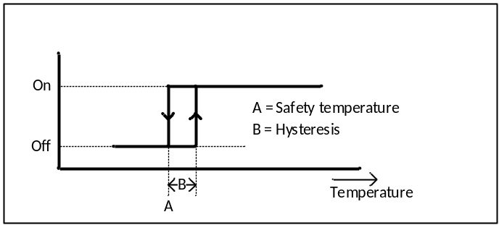
Figure 3: Spraying off based on safety temperature

Average night temperature
Cows are large animals, therefore it takes a while before heat stress is affecting the production and health. As long as cows are able to get rid of excessive heat during the night period the benefits of spray cooling are low. Therefore the user can set a minimum average night temperature. Which period should be seen as night period can differ from region to region, therefore the user can set a timeslot for the night period. When the average temperature during the night period is below this minimum the spraying will stay off during the day. This works fine as long as the weather is steady, but when the weather suddenly gets hot the spraying will only start after the first warm night.
To make clear weather spraying is allowed due to the average night temperature and to give uses the possibility to override this, the spraying allowed status is shown as a checkbox setting. The spraying allowed status is only updated during the night period, during the day period it can only be changed by the user.
Besides the spraying allowed checkbox also an easy button can be used to change the spraying allowed status. Just like the checkbox, the button can only be used during the day period. Every time the button is pressed the spraying allowed status toggles. The signal light indicates the actual spraying allowed status, in other words the light is on when spraying is allowed.

Timeslots
When activated in the installation menu, timeslots can be used to specify when the spraying may be active. The user can set up to 24 timeslots. Every timeslot exists of a start and a stop time. Start and stop times can be set from 0:00 to 23:59. In order to allow the spraying to be active the whole day the user can set a timeslot 0:00 – 24:00. Spraying is allowed when one (or more) of the timeslots is active. Although it doesn’t make sense, overlapping timeslots may be entered.
There can be different reasons to use timeslots, we will give a few examples:
- Off during night:
With timeslots it is possible to swich off the spraying during a part of the day, for example during the night when there is no influence of the sun.
- Cow presence:
In case there are no cows in a certain part of the barn, like the waiting room it doesn’t make sense to spray the whole day.

Maximum humidity
The relative humidity indicates how much water is absorbed in the air in relation to the maximum amount of water that can be absorbed. When humidity is high the air can’t absorb much water anymore and it takes longer before the water sprayed on the cows evaporates. The cooling gets less effective and the cows could get soaking wet. To avoid this the user can set a maximum humidity. When the humidity exceeds this limit the spraying valves will stop or stay off. To prevent excessive switching, a hysteresis function is provided. When there is no valid humidity available we assume the humidity is not too high to spray.
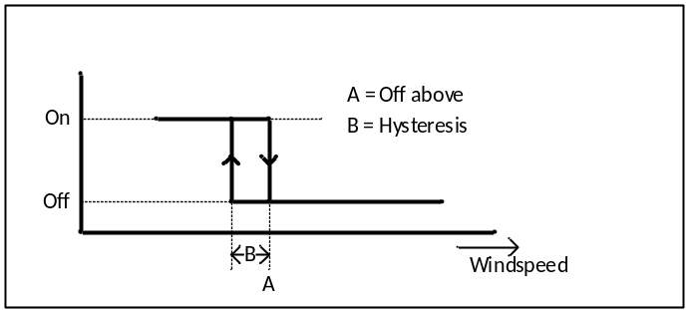
Figure 4: Spraying off based on humidity

Maximum windspeed
Dairy barns are often quite open, when its windy this is also causes an airflow inside the barn. From a certain windspeed there is a risk the water droplets come down on the wrong place, for example in the cubicles or on the food. To avoid this the user can set a maximum windspeed. When the windspeeds exceeds this limit the spraying valves will stop or stay off. To prevent excessive switching, a hysteresis function is provided. When there is no windspeed available we assume the windspeed is no too high to spray.
Figure 5: Spraying off based on windspeed

Cow presence
To prevent spraying when there are no cows present, cow presence detection can be used. The cow presence detection normally exists of light beam sensors that are mounted on the feeding fence. When there are cows present they will pierce their heads trough the fence to eat and break the light beam and the sensor will make the input high.

Runtime cycle and cycle time
On the BSC2 the spraying was activated for a certain runtime every time the cow presence input got high. When there were still cows present after the runtime was expired the spraying was activated for that runtime again. This had 2 disadvantages:
- Even a short interruption of the light beam triggered the spraying. This could lead to unnecessary spraying, for example when the cow presence detection was activated by a bird that flies trough the light beam or a farmer that is passing the feeding fence.
- It can lead to strange behaviour of the valves around the end of the runtime of the cycle. Since the runtime wasn’t necessarily a multiple of the cycle time, it can be that the cycle end at or just after the moment the valves where open. If there are still cows precent a new runtime starts and the valves can open again just after the closed. The figure below shows this situation.
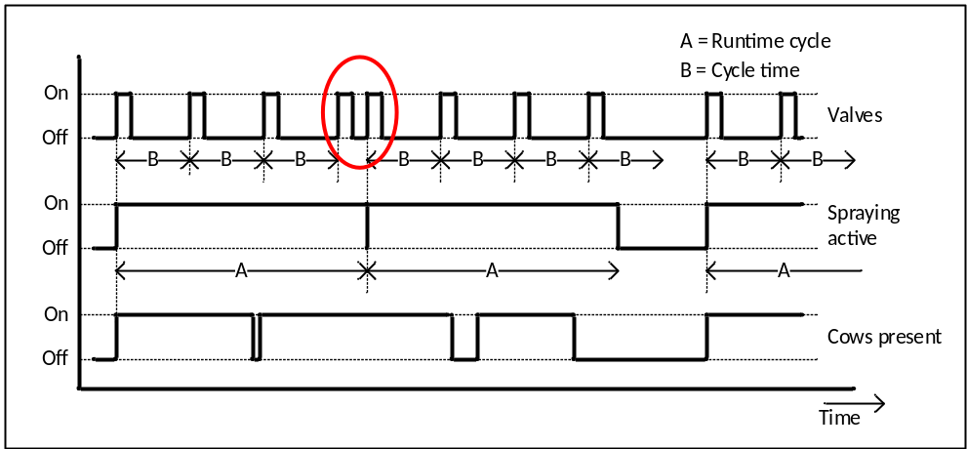
Figure 6: Strange switching of the valves with BSC2 control
To solve the problems described above, we want to improve the cow presence detection. Therefore we added 2 settings in the installation menu. With ‘Delay cow presence on’ we can set how long the light beam should be broken before the spraying is activated. This prevents that a short interruption of the light beam triggers the spraying. Since cows are normally quite slow a delay of about 10 seconds shouldn’t be a problem.
With ‘Delay cow presence OFF’ we can set how long the light beam shouldn’t see cows before spraying gets inactive. When the cows pull back their heads it doesn’t mean they aren’t present any more, therefore this time could be in the order 5 to 10 minutes. When the sensor sees no cows anymore (light beam unbroken) a timer starts to count until the light beam is broken or the delay cow presence off is expired. If the light beam is broken again the cow presence off timer should be reset, except when the interruption is shorter than ‘Delay cow presence on’.
The figure below shows a timing diagram for the spraying with cow presence detection, the spraying stays on as long as cows are detected. The setting runtime cycle is no longer needed so there can’t be strange behaviour at the end of a cycle.
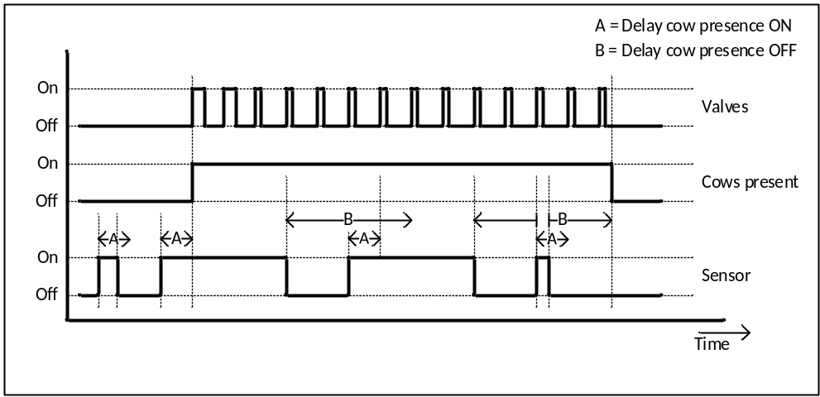
Figure 7: Spray control with improved cow presence detection,
The figure below shows the timing for the cow presence detection in more detail.
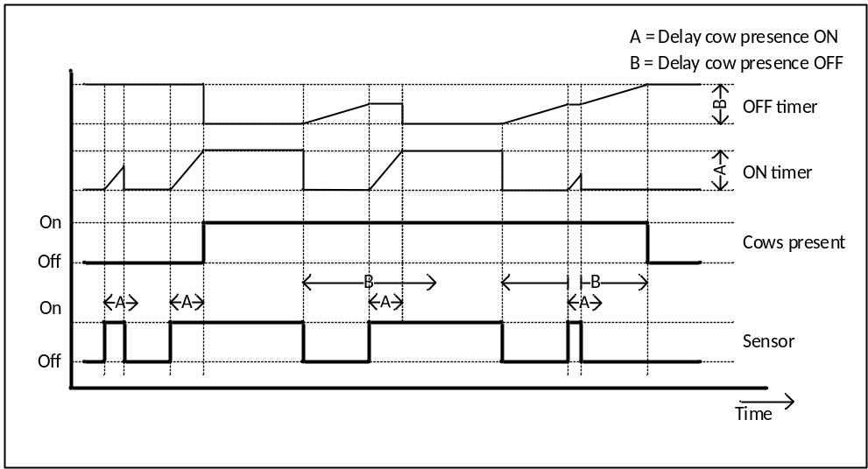
Figure 8: Cow presence detection, details for resetting internal timers

Override function
Sometimes user want to prevent the spraying for a certain time regardless the normal control. For example when the cows are fixated at the feeding fence for treatment or insemination. By setting the operation mode to off the spraying can be switched off, but using the override function has 3 advantages:
- With ‘Override duration’ the user can set how long the spraying must stay off. The spraying switches automatically back to normal operation when this time is expired, so the user cannot forget to set the spraying back to normal.
- When an override button is applied the spraying can be stopped easily by someone without knowledge of the controller.
Besides the ‘Override duration’ setpoint there is an ‘Override active’ checkbox. Here the user can see whether the override mode is active. By checking and unchecking the override checkbox the user can also activate and deactivate the override mode.
There are 2 ways to activate and deactivate the override mode:
- By checking and unchecking the override checkbox.
- By pushing the override button. When the button is pushed while the override mode is active the override mode will be deactivated.
The signal light in the override button shows whether the override mode is active.

Operation mode
The setting ‘Operation mode’ gives the user the possibility to switch the spraying on or off regardless the normal control. There are 3 options:
- Auto:
The spraying works according to the normal control.
- Off:
The spraying is off.
- Manual:
The spraying is active. In case of cyclic valve control the valves are switched on and off according to the maximum pulse time.
The setting operation mode is available per area.

Valve control
In the installation menu the installer can choose between the 2 following valve control modes:
- Cyclic:
In case the option ‘Cyclic’ is selected, the valves switch on and off based on a pulse and cycle time.
- Continuous:
The valves are continuously on when the spraying is active.
The cyclic mode is meant for spraying systems as described above, the continuous mode can be used for misting systems that require a continuous control. They were sometimes use in hot and dry climates.
Continuous mode doesn’t need much explanation, the valve output is switched on when the spraying gets active and the valve output is switched off when the spraying is no longer active. When the cyclic valve control mode is selected the control of the valve outputs is a bit more complicated. The output is switching according to a pulse and cycle time as shown in the figure below.
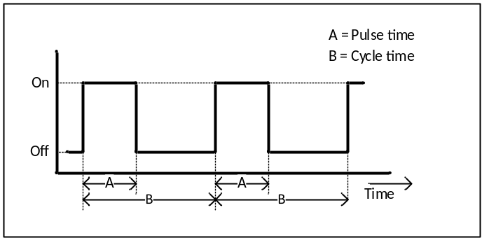
Figure 9: Cyclic valve control with pulse and cycle time
The pulse time is based on the measured value (temperature or THI) of the according area. Thus the cooling effect is stronger as the temperature or THI rises. The pulse time is calculated as shown in the figure below.
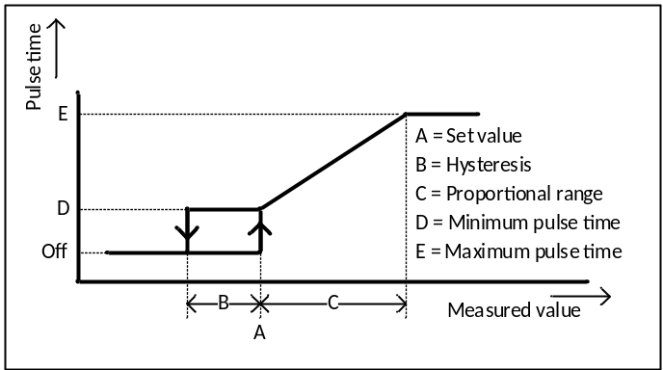
Figure 10: Variable pulse time
When the measured value is below or equal to the set value, the calculated pulse time is equal to the minimum pulse time. When the measured value is equal to or above the set value plus the proportional range, the pulse time is equal to the maximum pulse time. In between the pulse time is gradually increased from minimum to maximum.

Input ranges for pulse and cycle time
The settings for the minimum pulse time, the maximum pulse time and the cycle time are related. Normally the minimum pulse time is less than or equal to the maximum pulse time and the maximum pulse time is less than or equal to the cycle time. It might seems logical to limit the input range for the pulse and cycle time settings, but doing so would lead to a situation in which the user has to change the setting in a certain order. Therefore we deliberately choose not to do so and make sure the control can handle any input. When the pulse time is equal to (or higher than) the cycle time the spraying will be continuously on. When the pulse time is 0 the spraying will stay off.

Changing pulse time
When the spraying is active, the pulse time should be calculated every second so the spraying can react directly on changes of the measured value or the settings. The easiest way to implement the pulse and pause time is simply comparing the calculated pulse time with the actual cycle time. This method can cause problems, when the pulse time increases just after the output switched off it can cause the output to switch on for the second time during a cycle. This is undesirable, the cooling output should only switch on at the begin of the cycle. A change of the calculated pulse time should only have influence on the point the valves are switched off.
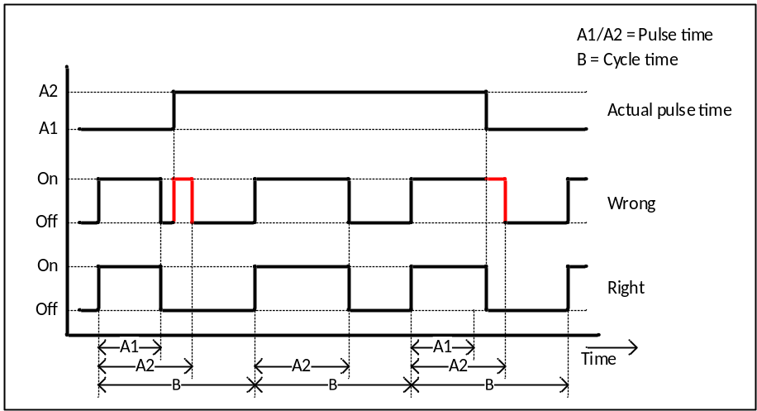
Figure 11: Switching diagram for pulse pause control and changing pulse time.
When the spraying gets active the cycle timer starts at zero so the cooling starts directly. When the spraying is no longer active it switches off directly. The hysteresis prevents the spraying switching between active and not active.

No link to the system time
On the BSC2, the timing of the valve control was directly related to the system time and the time the spraying got active. This could lead to all sort of strange behaviour for example in case settings like timeslots or the cycle time were changed or when the system time was changed. To avoid this we should work with a timer that is reset after every cycle.

Double pulse time
The fur of the animals is a bit greasy, therefore it take a while before the water reaches the skin of the cows when we start spraying. To compensate for this effect, the pulse time of the valves is doubled during the first two spraying cycles. In case the cycle time is less than twice the pulse time the spraying stay continuously on during the first 2 cycles.
In combination with cow presence detection this reasoning does not hold completely. When there are already cows present at the moment the temperature or THI gets too high it works fine, but when the cow cooling starts based on cow presence there are probably only just a few cows present.

Cyclic spraying and circulation fans
At circulation control the user can set ‘Delay fans off spraying on’ this means the fans should know it in advance when the spraying valves are switched on. Since circulation control cannot foresee the future, this delay must be implemented in spray control. When there are fans connected the pulse must not start at the begin of each cycle but after ‘Delay fans off valves on’.
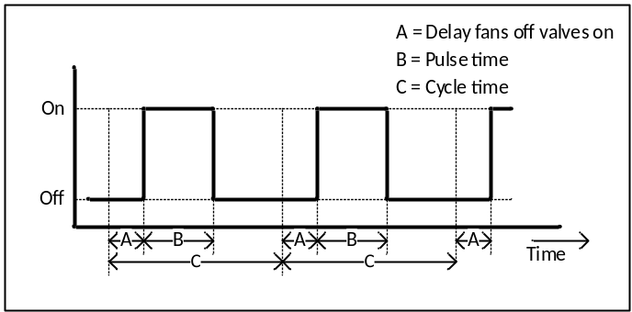
Figure 12: Cyclic control with delayed pulse .

Spraying percentage
For the BSC2 we had a BSC-monitor program that could be used to log data over the status of the different controls like cow cooling and mix ventilation. These data was stored on a minutes basis. A problem we encountered with a pulsating control like cow cooling is interference between the pulses and the minute based sampling. The figure below shows an example of this effect. Due to interference, the logged data looks completely different than the valve output.
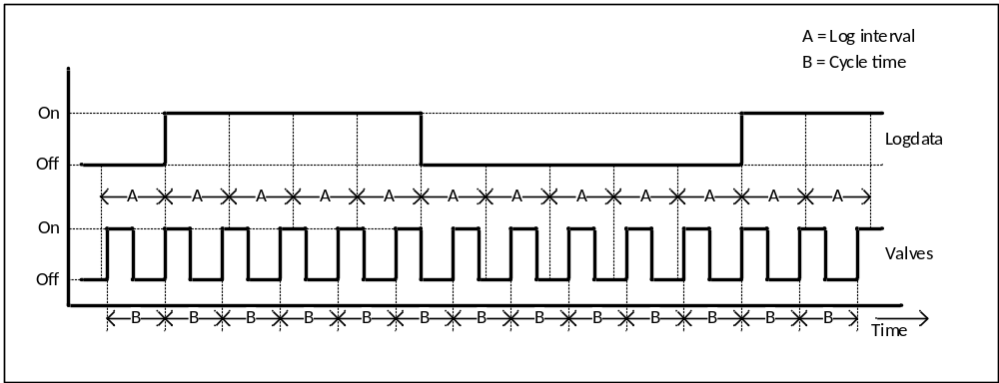
Figure 13: Interference between cycle time and log interval
On the BSC2 we solved this by counting the seconds the spraying was active per minute. The disadvantages of this method is that we still have some interference and that the data is always delayed. On our poultry computers we solved this problem by calculating the duty cycle based on the actual pulse and cycle time. This works as follows:
- In case the spraying isn’t active the duty cycle is 0%.
- In case the spraying is active and continuous valve control is selected the duty cycle is 100%.
- In case the spraying is active and a pulsating valve control is selected the duty cycle is calculated by dividing the actual pulse time by the cycle time. In case the pulse time is longer than the cycle time the duty cycle is 100%.
- In case the pulse time is doubled during the first 2 cycles, the duty cycle should also be doubled (to a maximum of 100%).
Please note: Data logging is not a part of this development, but to be prepared for the future we want to have this value available for every area and zone. Apart from that we could already display these values in the diagnosis screen.

Options
In the option screen of spray control we find the following sections and settings:

Spray control
Spray control
This option is available in case the option ‘Climate control’ and the module ‘CowCooling’ are activated. Here the installer can set with a checkbox whether spray control is used.
Control based on
This option is available in case the option ‘Spray control’ is activated and the option ‘THI’ is activated at ‘Climate control’. Here the installer can set how the spraying is controlled. There are 2 options:
- Temperature: The spraying is controlled based on temperature
- THI: The spraying is controlled based on THI
Default this option is on ‘Temperature’.
Type of valve control
This option is available in case the option ‘Spray control’ is activated. Here the installer can select how the spraying valves should be controlled. There are 3 options:
- Cyclic:
The valves work based on a variable pulse time. The pulse time varies between a set minimum and maximum based on the difference between the set value and the measured value.
- Continuous:
The valves go continuously on when spraying is active.
This option is default on ‘Cyclic’.

Average night temperature
Off based on low night temperature
This option is available in case the option ‘Spray control’ is activated. Here the installer can set with a checkbox whether the spraying should stay off based on a low average night temperature. This option is disabled by default.
Override button
This option is available in case the option ‘Off based on low night temperature’ is activated. Here the installer can set with a checkbox whether an easy button is used to override the blocking based on the average night temperature. This option is disabled by default.
Digital input
This option is available in case the option ‘Override button’ is activated. Here the installer can assign the digital input for the easy button.
Digital output
This option is available in case the option ‘Override button’ is activated. Here the installer can assign the digital output for the signal light of the easy button.

Temporary off
Temporary off button
This option is available in case the option ‘Spray control’ is activated. Here the installer can set with a checkbox whether an easy button to temporary switch off the spraying is used. This option is disabled by default.
Digital input
This option is available in case the option ‘Temporary off button’ is activated. Here the installer can assign the digital input for the easy button.
Digital output
This option is available in case the option ‘Temporary off button’ is activated. Here the installer can assign the digital output for the signal light of the easy button.

Areas
Number of spraying areas
This option is available in case the option ‘Spray control’ is activated. Here the installer can set how many areas of spraying should be controlled. This value can be set from 1 to 8 and has a default value of 1.
Set value per area
This option is available in case there is more than 1 area activated at the option ‘Number of areas’. Here the installer can set with a checkbox whether ‘Set value’ should be adjustable per area. This option is disabled by default.
When this option is disabled there is one ‘Set value’ setpoint that applies to all areas.
Sensor per area
This option is available in case there is more than 1 area activated at the option ‘Number of areas’. Here the installer can set with a checkbox whether the sensors should be assigned per area. This option is disabled by default.
When this option is disabled all areas work based on the average of the sensors assigned at climate control.

Area x (for x is 1 to 8)
The options in this section and the sections below are available for all activated areas.
Description
This option is available in case the regarding area is activated. Here the installer can set an alternative name for the regarding area. This name will be used in the user screens, so the user can easily recognize which area is meant. If there is no description entered the controller will use the name ‘Area 1’.
Temperature sensors
This option is available in case the regarding area is enabled and the option ‘Sensors per area’ is activated. Here the installer can assign up to 4 analog inputs for temperature measurement for the according area.
RH sensors
This option is available in case the regarding area is enabled and the option ‘Sensors per area’ is activated and the option ‘Control based on’ is set to THI. Here the installer can assign up to 2 analog inputs for RH measurement for the according area.
Timeslots
This option is available in case the regarding area is enabled and the option ‘Spray control’ is activated. Here the installer can set with a checkmark whether the user should be able to use timeslots for the regarding area. This option is disabled by default.
Cow presence
This option is available in case the regarding area is enabled and the option ‘Spray control’ is activated. Here the installer can set with a checkmark whether cow presence detection is use to determine whether spraying is useful. This option is disabled by default.
Cow presence sensor delay on
This option is available in case the regarding area is enabled and the option ‘Cow presence’ is activated. Here the installer can set how long the light beam of the cow presence detection should be broken before the spraying is activated. This value can be set from 0 to 60 seconds and has a default value of 10 seconds.
Cow presence sensor delay off
This option is available in case the regarding area is enabled and the option ‘Cow presence’ is activated. Here the installer can set how long the sensor should detect no cows before the spraying is deactivated. This value can be set from 0 to 60 minutes and has a default value of 10 minutes.
Number of zones
This option is available in case the regarding area is enabled and the option ‘Cow presence’ is activated. Here the installer can set in how many spraying zones is controlled. This value can be set from 1 to 4 and has a default value of 1.
Per zone a digital input for the sensor and a digital output for the vales are needed.
Digital inputs cow presence sensors
This option is available in case the regarding area is enabled and the option ‘Cow presence’ is activated. Here the installer can assign a digital input per zone for the cow presence sensors. The number of inputs that is assigned should be equal to the number of zones.
Digital outputs
This option is available in case the regarding area is enabled and the option ‘Cow presence’ is activated. Here the installer can assign a digital output per zone for the water valves. The number of outputs that is assigned should be equal to the number of zones.
Digital output
This option is available in case the regarding area is enabled and the option ‘Cow presence’ is activated isn’t activated. Here the installer can assign the digital output for the water valves. The number of outputs that is assigned should be equal to the number of zones.

Setpoints
In the setpoint screen of spray control we find the following sections and settings:

Spray control
Override active
This setting is always available in case the circulation fan control is activated. Here the user set with a checkbox whether override mode is active. When override mode is activated the fans switch on at the specified level. When the override duration is exceed the switch back to their normal level and the ‘Override active’ checkbox is unchecked. By unchecking the ‘Override active’ checkbox it is also possible to stop override mode earlier.
Please note: The checkbox also reacts when the button is used to activate or deactivate override mode.
Override duration
This setpoint is always available in case the spraying is activated. Here the user can set how long the spraying should stay in override mode. When this time is exceeded the spraying goes automatically back to the normal level. This value can be set from 0:00 to 24:00 and has a default value of 1:00.

Temperature control
Set value
This setpoint is available in case the spraying valves are controlled based on temperature and the option ‘Set value per area’ isn’t activated. Here the user can set the set the point where the spraying gets active. This value can be set from 0.0 to 50.0 °C and has a default value of 25.0 °C.
Hysteresis
This setpoint is available in case the spraying valves are controlled based on temperature. Here the user can set how far the temperature should drop below the set value before the spraying is no longer active. This value can be set from 0.0 to 10.0 °C and has a default value of 0.5 °C.

THI control
Set value
This setpoint is available in case the spraying valves are controlled based on THI and the option ‘Set value per area’ isn’t activated. Here the user can set the set the point where the spraying gets active. This value can be set from 0 to 100 and has a default value of 63.
Hysteresis
This setpoint is available in case the circulation fans are controlled based on THI. Here the user can set how far the THI should drop below the set value before the spraying is no longer active. This value can be set from 0 to 10 and has a default value of 1.
Safety temperature
This setpoint is available in case the spraying valves are controlled based on THI. Here the user can set below which temperature the spraying is switched off regardless the THI. This value can be set from 0.0 to 50.0 °C and has a default value of 25.0 °C.
Safety hysteresis
This setpoint is available in case the circulation fans are controlled based on THI. Here the user can set how far the temperature should rise above the safety temperature before the spraying valves may switch on again. This value can be set from 0.0 to 10.0 °C and has a default value of 0.5 °C.

Average night temperature
Spraying allowed
This setpoint is available in case the option ‘Off based on low night temperature’ is activated. Here the user can see whether spraying is allowed based on the average night temperature. This is represented by a checkbox. The state of the checkbox is only updated during the night period or when the setting for the minimum average night temperature is changed. During the day period the user can simply overrule the decision made based on the average night temperature by checking or unchecking this checkbox.
To make clear ‘Spraying allowed’ can’t be changed, the checkbox should be grey during the night period.
Night period
This setpoint is available in case the option ‘Off based on low night temperature’ is activated. Here the user can set a start and stop time for the night period. The start and stop time can both be set from 0:00 to 23:59. The default night period is 22:00 – 8:00.
Minimum average night temperature
This setpoint is available in case the option in case the option ‘Off based on low night temperature’ is activated. Here the user can set above which average night temperature spraying is allowed. This value can be set from 0.0 to 50.0 °C and has a default value of 18.8 °C.

Humidity
Spraying off above
This setpoint is available in case the option ‘Humidity’ is activated at climate control. Here the user can set above which humidity the spraying should switch off. This value can be set from 0 to 100 % and has a default value of 71 %.
Hysteresis
This setpoint is available in case the option ‘Humidity’ is activated at climate control. Here the user can set how far the humidity should drop below ‘Spraying off above’ before the spraying may switch on again. This value can be set from 0 to 100 % and has a default value of 5 %.

Windspeed
Spraying off above
This setpoint is available in case the option ‘Windspeed’ is activated at the weather station. Here the user can set above which windspeed the spraying should switch off. This value can be set from 0.0 to 30.0 m/s and has a default value of 6.0 m/s.
Hysteresis
This setpoint is available in case the option ‘Windspeed’ is activated at the weather station. Here the user can set how far the windspeed should drop below ‘Spraying off above’ before the spraying may switch on again. This value can be set from 0.0 to 30.0 m/s and has a default value of 0.5 m/s.

Valve control
Minimum pulse time
This setpoint is available in case the regarding area is enabled and the option ‘Valve control’ is set to ‘Cyclic’. Here the user can set the minimum pulse time for the valves. This value can be set from 0 to 999 seconds and has a default value of 20 seconds.
Maximum pulse time
This setpoint is available in case the regarding area is enabled and the option ‘Valve control’ is set to ‘Cyclic’. Here the user can set the maximum pulse time for the valves. This value can be set from 0 to 999 seconds and has a default value of 30 seconds.
Cycle time
This setpoint is available in case the option ‘Valve control’ is set to ‘Cyclic. Here the user can set the cycle time for the valves. This value can be set from 0 to 999 seconds and has a default value of 120 seconds.
Proportional range
This setpoint is available in case the regarding area is enabled and the spraying valves are controlled based on temperature and the option ‘Valve control’ is set to ‘Cyclic’. Here the user can set how far the temperature should be above the set value before the pulse time of the valves is at maximum. This value can be set from 0.0 to 50.0 °C and has a default value of 2.0 °C.
Proportional range
This setpoint is available in case the regarding area is enabled and the spraying valves are controlled based on THI and the option ‘Valve control’ is set to ‘Cyclic’. Here the user can set how far the THI should be above the set value before the pulse time of the valves is at maximum. This value can be set from 0 to 50 and has a default value of 3.

Area x (for x is 1 to 8)
The setpoints in this section are available for all activated areas.
Operation mode
This setpoint is always available in case the according area is enabled. Here the user can set how the spraying valves should operate. There are 3 options:
- Automatic: The spraying valves working according to the normal control.
- Off: The spraying valves are off.
- On: The spraying valves are on at maximum level.
By default this setting is on ‘Automatic’.
Timeslots
This setpoint is available in case the regarding area is enabled and the option ‘Timeslots’ is activated. Here the user can set up to 24 start/stop times to determine when the spraying may be active. The setting shows the actual timeslot. There is a button to enter a sub screen. Here the user can see all time slots and change the timeslots. The sub screen also gives a graphical representation of the set timeslots.
Please note: To reduce complexity we leave out the setting for the ‘Duration on’ so the user only has the possibility to use start and stop times.
Set value
This setpoint is available in case the regarding area is enabled and the spraying valves are controlled based on temperature and the option ‘Set value per area’ is activated. Here the user can set the point where the spraying gets active. This value can be set from 0.0 to 50.0 °C and has a default value of 25.0 °C.
Set value
This setpoint is available in case the regarding area is enabled and the spraying valves are controlled based on THI and the option ‘Set value per area’ is activated. Here the user can set the set the point where the spraying gets active. This value can be set from 0 to 100 and has a default value of 63.

Main group
The main group or of spray control shows the following items:
- The actual status:
In case the spraying in one or more of the zones is active the main value shows ON, otherwise it shows OFF.
In case the override function is active we should also see the remaining time.
- Right from the main item we see following items:
  - Actual value (temperature or THI)
  - Set value(temperature or THI)
  - The actual timeslot:
- Below the main item we see an icon bar that indicates why the spraying doesn’t run according to normal control.
  - Windspeed
  - Timeslots off
  - Safety temperature
  - Average night temperature
  - Override mode active
  - Operation mode not on automatic
- A bar chart that shows the actual value of the areas and or zones.

Diagnosis
In the diagnosis screen of the spray control we find following items:
- Per digital output
  - The actual value e.g. ‘On’ or ‘Off’
  - The assigned output
  - The duty cycle (in case of cyclic valve control)
In case sensors per area is activated we also find:
- The assignments and actual values of the sensors.
- The actual control value of the areas (temperature or THI).
In case there are several areas the information is shown per area.

Alarms
Spray control has no alarms.

Circulation fans
Circulation fans are designed to efficiently displace a huge volume of air with a low counter pressure. Unlike exhaust fans, circulation fans are fans used to create an airflow within the barn. The main goal of circulation fans is to provide a cooling airflow over the animals. Usually these fans are mounted hanging from the roof above the cows. They are slightly tilted so the airflow is aimed downward to the animals.
In addition they help to create a more evenly climate. Because dairy barns are quite open circulating the air also causes extra ventilation.

Hardware
DeLaval uses following configurations to control the fans:
- FRB (Fan Relay Box):
The FRB is a control box with four 3-phase relays that can be used to switch on/off controlled fans.
- MFS (Multi Fan Speed control):
The MFS is a frequency drive used to control the speed of multiple fans. There are 2 versions of the MFS: a 10 Amp and a 16 Amp version. To control the MFS an analog and a digital out are needed.
- SFS (Single Fan Speed control):
The SFS is a frequency drive used to control the speed of a single fan. Like the MFS an analog and a digital out are needed to control the SFS.

Controls
Circulation control is build up from a number of functions of which some are optional and some are always active. In this chapter we will discuss all these functions separately. The figures below schematically shows how these different functions interact.
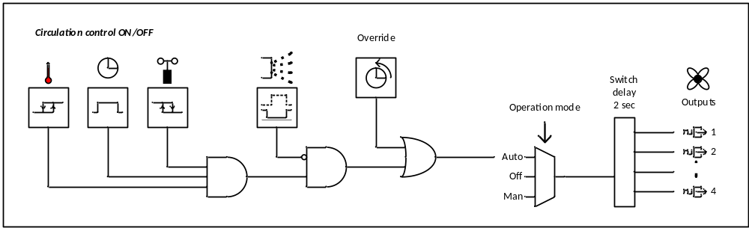
Figure 14: Schematic overview of ON/OFF circulation control
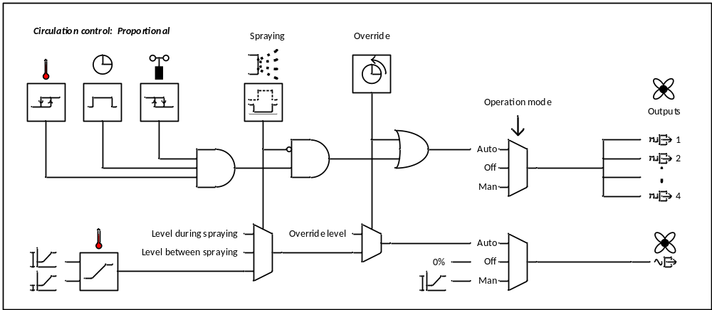
Figure 15: Schematic overview of proportional circulation control

Areas and groups
The circulation can be divided over different groups and/or areas. Areas are used when circulation fans in separate parts of the barn require different settings and/or different temperature/RH sensors. Groups can be used in case want to control fans on the same settings and sensors, but want to switch them on in different groups or adjust the fan speed for a part of the area due to spraying.

Circulation control
Basically the circulation fans are controlled based on the difference between the measured value and the set value. This can be based on temperature or on THI. In addition to this main control there can be extra conditions like timeslots and override functions that determine whether the circulation fans should be on or not. Depending on the hardware configuration the circulation fans are controlled with an on/off control or a proportional control.
When there is no valid measured value available, the circulation fans are switched off.

On/off control
In case of an ‘on/off control’ the controller switches the fans on and off based on the measured value. The fans are switched on when the measured value is equal to or higher than the set value and switched off when the measured value is lower than the set value minus the hysteresis.
Figure 16: Main on/off circulation control based on temperature or THI
Basically all fans switch at the same time although a switching delay of 2 seconds is used to reduce the inrush current when the fans are divided over several groups.

Proportional control
In case of a ‘proportional control’ the controller uses an analog outputs to adjust the ventilation level and a digital outputs to switch the fans on and off. The ventilation level is represented by a percentage. Due to physical limitations, fans have a certain minimum capacity, therefore the percentage is not directly proportional to the capacity but works as follows: at 0% the fans are off, at 1% the fans are on at minimum level, at 100% the fans are on at maximum level, between 1 and 100% the ventilation level gradually increases from minimum to maximum.
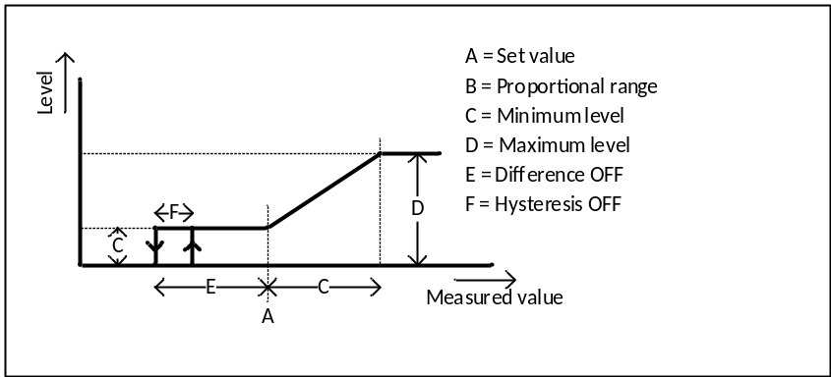
Figure 17: Main proportional circulation control based on temperature or THI
When the measured value is below or equal to the ‘Set value’, the ventilation level is at minimum. When the measured value is at or above ‘Set value’ plus ‘Proportional range’ the ventilation level is at maximum. In between the ventilation level is gradually increased from minimum to maximum. When the measured value drops below the set value there is a point where its better to switch off the fans completely than leaving them on at minimum. This point can be set with ‘Difference off’ and works as follows. The fans are switched off when de measured value is below ‘Set value’ minus ‘Difference off' and switched on when the measured value is equal to or higher than the ‘Set value’ minus ‘Difference off' plus ‘Hysteresis’.

Per area
The main control based on temperature or THI is evaluated per area. In case the option ‘Set value per area’ is activated, there is a separate set value for every area. In case the option sensors per area is activated the actual temperature or THI is determined per area, otherwise this control works on the actual value (average temperature or THI) determined by climate control.
In case a sensor is defective or set out of use at climate control it should also not be used to determine the measured value of an area. In case there are no valid sensors left for an area, the average value determined by climate control is used instead.

Timeslots
When activated in the installation menu, timeslots can be used to specify when the circulation fans may switch on. The user can set up to 24 timeslots. Every timeslot exists of a start and a stop time. Start and stop times can be set from 0:00 to 23:59. In order to allow the fans to be on the whole day the user can set a timeslot 0:00 – 24:00. Circulation is allowed when one (or more) of the timeslots is active. Although it doesn’t make sense overlapping timeslots may be entered.
There can be different reasons to use timeslots, we will give a few examples:
- Off during night:
With timeslots it is possible to swich off the fans during a part of the day, for example during the night when there is no influence of the sun.
- Cow presence:
In case there are no cows in a certain part of the barn, like the waiting room it doesn’t make sense to leave the fans on the whole day.
- Peak shaving:
When the power supply is too tight it can be useful to switch off fans during milking, when vacuum pump and the cooling of the milk take a lot of power.

Maximum windspeed
Dairy barns are often quite open, so when its windy outside there will also be an airflow inside the barn. From a certain windspeed it makes no sense to use the circulation fans since the airflow caused by the wind is higher than the airflow caused by the fans.
Therefore, the user can set a above which windspeed the circulation fans should switch off when the windspeed is activated at weather station. The circulation fans switch off when the average windspeed exceeds the set limit. To prevent excessive switching of the fans, a hysteresis function is provided.
Figure 18: Spraying off based on windspeed

Override function
Sometimes user want to start the circulation fans for a certain time regardless the normal control. For example when it gets stinky in barn during winter or when they have to mix the manure. By setting the operation mode to manual the fans can be switched on at maximum level, but using the override function has 3 advantages:
- With ‘Override duration’ the user can set how long the fans may stay in override mode. The fans switch automatically back to normal operation when this time is expired, so the user cannot forget to set the fans back to normal.
- With ‘Override level’ the user can set the desired level in override mode separately so it doesn’t affect the normal settings.
- When an override button is applied the fans can be started easily by someone without knowledge of the controller.
Besides the ‘Override duration’ and the ‘Override level’ setpoints there is an ‘Override active’ checkbox. Here the user can see whether the override mode is active. By checking and unchecking the override checkbox the user can also activate and deactivate the override mode.
There are 2 ways to activate and deactivate the override mode:
- By checking and unchecking the override checkbox.
- By pushing the override button. When the button is pushed while the override mode is active the override mode will be deactivated.
The signal light in the override button shows whether the override mode is active.

Operation mode
The setting ‘Operation mode’ gives the user the possibility to switch the circulation fans on or off regardless the normal control. There are 3 options:
- Auto:
The circulation fans works according to the normal control.
- Off:
The circulation fans are off.
- Manual:
The circulation fans are active. In case of cyclic valve control the valves are switched on and off according to the maximum pulse time.
The setting operation mode is available per area.

Outputs per group
In the installation procedure it is possible to activate up to four groups per area. There can be 2 reasons to use several groups per area:
- Reduce the inrush current:
- Reducing the ventilation level during spraying:
In the sections below we will explain this a bit further.

Reducing inrush current
When fans are switched on by a relay they at first act like a shortcut, this can lead to an inrush current that’s six times higher than the nominal current of the fans. Switching a lot of fans at once can lead to a dip of the main voltage. To reduce the current peak the fans can be divided over several groups that are switched on with a delay of 2 seconds. This 2 seconds should also be taken into account if the fans are divided over several areas.
When the fans are controlled proportionally we may assume that there are always frequency drives used that provide a soft start, so there is no need to avoid a too high inrush current by using the switching delay.

Reducing the ventilation level during spraying
During spraying the airflow of the circulation fans can blow the water droplets to the wrong spot, for example in the cubicles or on the feed. To prevent this the ventilation level can be reduced. By using groups it is possible to reduce the ventilation level only in the part of the area where the spraying is active. In case of proportionally controlled fans the reduction of the ventilation level can be achieved by adjusting the ventilation level or switching them off. In case of on/off controlled fans the only way to reduce the ventilation level is to switch them of entirely.

Connected to spraying
In the installation menu the groups of the circulation fans can be connected to areas and/or zones of the spray control. There are 2 different ways to connect the fans to the spraying: ‘Reduce level during spraying’ and ‘Switch off during spraying’. For on/off controlled fan we can only choose to switch them off, for proportionally controlled fans we can choose whether we want to reduce speed or switch off. Connecting the circulation to the spraying serves 2 purposes. We will explain this based on on/off controlled fans:
- When the spraying is active and the valves are open the fans are switched off. This prevents that the water droplets are blown to wrong place, for example on the feed or in the cubicles.
- When the spraying is active and the valves are closed the fans are switched on. To create an extra airflow to create a cooling effect for the cows.
When the fans are switched off the airflow doesn’t stop instantly. To avoid the first droplets still coming down on the wrong place, ‘Delay fans off valves on’ can be used to delay the spraying valves.
When the spraying stops the cows are still wet, therefore the fans should stay on for a while when the spraying is not active anymore. With ‘Runout time’ the user can set how long the fans should stay on after the spraying gets inactive.
The figure below shows a timing diagram for on/off controlled circulation fans when the spraying is active.
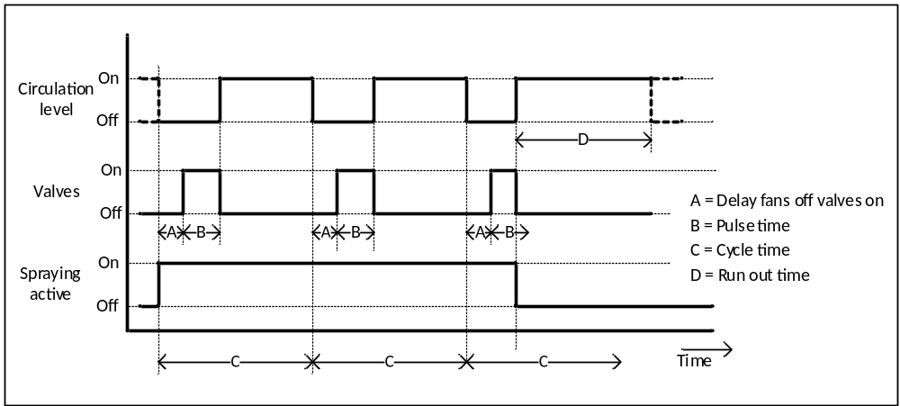
Figure 19: Circulation fans when spraying active
In case ‘Reduce level during spraying’ is activated, the timing stays the same. The only difference is that we can set the ventilation levels. Therefore 2 extra settings appear:
- Level when valves ON:
This is the level for the fans when the spraying is active and the valves are on.
- Level when valves OFF:
This is the level for the fans when the spraying is active and the valves are off and during the runout time.
Since circulation control cannot know whether spraying will get active in future, spraying should delay the valves a bit to give the fans the chance to reduce speed.

Options
In the option screen of spray control we find the following sections and lines:

Circulation fan control
Circulation fan control
This option is available in case the option ‘Climate control’ and the module ‘CowCooling’ is activated. Here the installer can set with a checkbox whether circulation fan control is used.
Control based on
This option is available in case the option ‘Circulation fan control’ is activated and the option ‘THI’ is activated at ‘Climate control’. Here the installer can set how the circulation fans are controlled. There are 2 options:
- Temperature: The circulation is controlled based on temperature
- THI: The circulation is controlled based on THI
Default this option is on ‘Temperature’.
Type of control
This option is available in case the option ‘Circulation fan control’ is activated and the option ‘THI’ is activated at ‘Climate control’. Here the installer can set how the circulation fans are controlled. There are 2 options:
- On/off:
The circulation fans can only be switched on and off by digital outputs.
- Proportional:
The level of the circulation fans is controlled by analog outputs, in addition the circulation fans can be switched on and off by digital outputs.
Default this option is on ‘On/Off.

Temporary on
This section contains options regarding to the override button. The override button is meant to easily switch on the circulation fans for a limited time regardless of the normal controls. The limited time prevents the risks that the fans stay on too long because the user is busy with other tasks (or simply forgets to switch them off).
Override button
This option is always available in case circulation control is activated. Here the installer can set with a checkbox whether an easy button is used to switch the fans on temporary. This option is disabled by default.
Digital input
This option is available in case the option ‘Override button’ is activated. Here the installer can assign the digital input for the easy button.
Digital output
This option is available in case the option ‘Override button’ is activated. Here the installer can assign the digital output for the signal light of the easy button.

Areas
Number of circulation areas
This option is available in case the option ‘Circulation fan control’ is activated. Here the installer can set how many areas of spraying should be controlled. This value can be set from 1 to 8 and has a default value of 1.
Set value per area
This option is available in case there is more than 1 area activated at the option ‘Number of areas’. Here the installer can set with a checkbox whether the set value should be adjustable per area. This option is disabled by default.
When this option is disabled there is one set value that applies to all areas.
Sensor per area
This option is available in case there is more than 1 area activated at the option ‘Number of areas’. Here the installer can set with a checkbox whether the sensors should be assigned per area. This option is disabled by default.
When this option is disabled all areas work based on the average of the sensors assigned at climate control

Area x (for x is 1 to 8)
The options in this section and the sections below are available for all activated areas.
Description
This option is available in case the regarding area is activated. Here the installer can set an alternative name for the regarding area. This name will be used in the user screens, so the user can easily recognize which area is meant. If there is no description entered the controller will use the name ‘Area x’.
Temperature sensors
This option is available in case the option ‘Sensors per area’ is activated. Here the installer can assign up to 4 analog inputs for temperature measurement for the according area.
RH sensors
This option is available in case the option Sensors per area’ is activated and the option ‘Type of control’ is set to THI. Here the installer can assign up to 2 analog inputs for RH measurement for the according area.
Timeslots
This option is available in case the according area is activated. Here the installer can set with a checkmark whether the user should be able to use timeslots for the regarding area. This option is disabled by default.
Number of groups
This option is available in case the according area is activated. Here the installer can set over how many groups the fans of the according area are divided. This value can be set from 1 to 4 and has a default value of 1.
Analog outputs per group
This option is available in case the option ‘Type of control’ is set to ‘Proportional’ and the number of groups is higher than 1. Here the installer can set with a checkbox whether there are analog outputs per group.
Analog outputs
This option is available in case the option ‘Type of control’ is set to ‘Proportional’. Here the installer can assign the analog outputs for the circulation fans. There are 2 situations:
- In case the option ‘Analog outputs per group’ is activated, the number of outputs that can be assigned is equal to the number of groups.
- In other cases the number of outputs that can be assigned is 1.
Digital outputs per group
This option is available in case the option ‘Analog outputs per group’ is activated. Here the installer can set with a checkbox whether there are digital outputs per group.
Please note: In case there are groups but no analog outputs per group we already know there have to be digital outputs per group, so this option is hidden.
Digital outputs
This option is available in case the according area is activated. Here the installer can assign the digital outputs for circulation fans. There are 3 situations:
- In case the option ‘Digital outputs per group’ is activated, the number of outputs that can be assigned is equal to the number of groups.
- In case the option ‘Analog outputs per group’ is not activated, the number of outputs that can be assigned is equal to the number of groups.
- In other cases the number of outputs that can be assigned is 1.

Area x connect to spraying x (for x is 1 to 8)
Reduce fan speed at spraying
This option is available in case the option ‘Spray control’ is activated and the option ‘Type of control’ is set to ‘Proportional’. Here the installer can set with a checkbox whether the speed of the connected fans should be reduced during spraying. This option is disabled by default.
Fans off at spraying
This option is available in case the option ‘Spray control’ is activated and the option ‘Reduce fan speed at spraying’ is disabled. Here the installer can set with a checkbox whether the connected fans should be switched off during spraying. This option is disabled by default.
Select groups to connect
This option is available in case the number of circulation groups is more than one and one of the options ‘Reduce fan speed at spraying’ or ‘Fans off at spraying’ is activated. Here the installer can select with a list of checkboxes whether the according groups should be connected to spraying control. These option is disabled by default.

Area x select spraying to connect to group y (for x is 1 to 8, and y is 1 to 4)
The options in this section are available for every group that’s connected to spraying.
Select spraying areas
This option is available in case there is more than 1 spraying area activated. Here the installer can select with a list of checkboxes which spraying areas should cause the circulation fans to reduce speed or swich off.
Select spraying zones area x
This option is available for every selected spraying area with more than one zone. Here the installer can select with a list of checkboxes which zones of the according spraying area should cause the circulation fans to reduce speed or swich off.

Setpoints
In the setpoint screen of circulation fan control we find the following sections and lines:

Circulation fan control
Override active
This setpoint is always available in case the circulation fan control is activated. Here the user set with a checkbox whether override mode is active. When override mode is activated the fans switch on at the specified level. When the override duration is exceed the switch back to their normal level and the ‘Override active’ checkbox is unchecked. By unchecking the ‘Override active’ checkbox it is also possible to stop override mode earlier.
Please note: The checkbox also reacts when the button is used to activate or deactivate override mode.
Override duration
This setpoint is always available in case the circulation fan control is activated. Here the user can set how long the circulation fans should stay in override mode. When this time is exceeded the fans go automatically back to their normal level. This value can be set from 0:00 to 24:00 and has a default value of 1:00.
Override level
This setpoint is available in case the option ‘Type of control’ is set to ‘Proportional’. Here the user can set the override level. This is the ventilation level while override is active. This value can be set from 0 to 100 % and has a default value of 10 %.

Temperature control
Set value
This setpoint is available in case the circulation fans are controlled based on temperature and the option ‘Set value per area’ isn’t activated. Here the user can set the set value. In case the fans are controlled proportionally this is the point above which the ventilation level starts rising. In case of an on/off control this is the point where the fans switch on. This value can be set from 0.0 to 50.0 °C and has a default value of 30.0 °C.
Hysteresis
This setpoint is available in case the circulation fans are controlled based on temperature and the option ‘Type of control’ is set to ‘On/off. Here the user can set how far the temperature should drop below the set value before the circulation fans switch of. This value can be set from 0.0 to 10.0 °C and has a default value of 0.5 °C.
Minimum level
This setpoint is available in case the circulation fans are controlled based on temperature and the option ‘Type of control’ is set to ‘Proportional’. Here the user can set the minimum level. This value can be set from 0 to 100 % and has a default value of 10 %.
Maximum level
This setpoint is available in case the circulation fans are controlled based on temperature and the option ‘Type of control’ is set to ‘Proportional’. Here the user can set the maximum level. This value can be set from 0 to 100 % and has a default value of 100 %.
Please note: The minimum and maximum level of temperature control and THI control should refer to the same setpoint.
Proportional range
This setpoint is available in case the circulation fans are controlled based on temperature and the option ‘Type of control’ is set to ‘Proportional’. Here the user can set how far the temperature should be above the set value before the circulation fans go to maximum level. This value can be set from 0.0 to 50.0 °C and has a default value of 5.0 °C.
Difference off
This setpoint is available in case the circulation fans are controlled based on temperature and the option ‘Type of control’ is set to ‘Proportional’. Here the user can set how far the set temperature should drop below the set value before the circulation fans switch off completely. This value is set as a difference to the set value. Both the difference and the calculated value should be visible. This value can be set from -50.0 to 0.0 °C and has a default value of 0.0 °C.
Hysteresis off
This setpoint is available in case the circulation fans are controlled based on temperature and the option ‘Type of control’ is set to ‘Proportional’. Here the user can set how far the set temperature should rise above the point set with difference off before the circulation fans switch on again. This value can be set from 0.0 to 10.0 °C and has a default value of 0.5 °C.

THI control
Set value
This setpoint is available in case the circulation fans are controlled based on THI and the option ‘Set value per area’ isn’t activated. Here the user can set the set value. In case the fans are controlled proportionally this is the point above which the ventilation level starts rising. In case of an on/off control this is the point where the fans switch on. This value can be set from 0 to 100 and has a default value of 63.
Hysteresis
This setpoint is available in case the circulation fans are controlled based on THI and the option ‘Type of control’ is set to ‘On/off. Here the user can set how far the THI should drop below the set value before the circulation fans switch of. This value can be set from 0 to 10 and has a default value of 1.
Minimum level
This setpoint is available in case the circulation fans are controlled based on THI and the option ‘Type of control’ is set to ‘Proportional’. Here the user can set the minimum level. This value can be set from 0 to 100 % and has a default value of 10 %.
Maximum level
This setpoint is available in case the circulation fans are controlled based on THI and the option ‘Type of control’ is set to ‘Proportional’. Here the user can set the maximum level. This value can be set from 0 to 100 % and has a default value of 100 %.
Please note: The minimum and maximum level of temperature control and THI control should refer to the same setpoint.
Proportional range
This setpoint is available in case the circulation fans are controlled based on THI and the option ‘Type of control’ is set to ‘Proportional’. Here the user can set how far the THI should be above the set value before the circulation fans go to maximum level. This value can be set from 0 to 50 and has a default value of 9.
Difference off
This setpoint is available in case the circulation fans are controlled based on THI and the option ‘Type of control’ is set to ‘Proportional’. Here the user can set how far the THI should drop below the setpoint before the circulation fans switch off completely. This value is set as a difference to the set value. Both the difference and the calculated value should be visible. This value can be set from -50 to 0 and has a default value of 0.
Hysteresis off
This setpoint is available in case the circulation fans are controlled based on temperature and the option ‘Type of control’ is set to ‘Proportional’. Here the user can set how far the set temperature should rise above the point set with difference off before the circulation fans switch on again. This value can be set from 0 to 10 and has a default value of 1.

Windspeed
Fans OFF above
This setpoint is available in case the option ‘Windspeed’ is activated at the weather station. Here the user can set above which windspeed the circulation fans should switch off. This value can be set from 0.0 to 30.0 m/s and has a default value of 6.0 m/s.
Hysteresis
This setpoint is available in case the option ‘Windspeed’ is activated at the weather station. Here the user can set how far the windspeed should drop below ‘Fans off above’ before the circulation fans switch on again. This value can be set from 0.0 to 30.0 m/s and has a default value of 0.5 m/s.

Spraying
Level when valves on
This setpoint is available in case circulation control is connect to spraying and the circulation is controlled proportionally. Here the user can set the level for the connected fans when spraying is active and the valves are open. This value can be set from 0 to 100 % and has a default value of 30 %.
Level when valves off
This setpoint is available in case circulation control is connect to spraying and the circulation is controlled proportionally. Here the user can set the level for the connected fans when spraying is active and the valves are closed. This value can be set from 0 to 100 % and has a default value of 100 %.
Delay fans off valves on
This setpoint is available in case circulation control is connect to spraying. Here the user can set how long before spraying starts t. This value can be set from 0 to 120 seconds and has a default value of 0 seconds.
Delay fans off after spraying
This setpoint is available in case circulation control is connect to spraying. Here the user can set how long the fans should stay on after the valves are closed. This value can be set from 0 to 999 seconds and has a default value of 0 seconds.

Area x (for x is 1 to 8)
The setpoints in this section are available for all activated areas.
Operation mode
This setpoint is always available in case the circulation fan control is activated. Here the user can set how the circulation fans should operate. There are 3 options:
- Automatic: The circulation fans working according to the normal control.
- Off: The circulation fans are off.
- On: The circulation fans are on at maximum level.
By default this setting is on ‘Automatic’.
Timeslots
This setpoint is available in case the options ‘Timeslots’ is activated. Here the user can set up to 24 start/stop times to determine when the circulation fans may be active. The setting shows the actual timeslot. There is a button to enter a sub screen. Here the user can see all timeslots and change the timeslots. The sub screen also gives a graphical representation of the set timeslots.
Please note: To reduce complexity we leave out the setting for the ‘Duration on’ so the user only has the possibility to use start and stop times.
Set value
This setpoint is available in case the circulation fans are controlled based on temperature and the option ‘Set value per area’ is activated. Here the user can set the set value. In case the fans are controlled proportionally this is the point above which the ventilation level starts rising. In case of an on/off control this is the point where the fans switch on. This value can be set from 0.0 to 50.0 °C and has a default value of 30.0 °C.
Set value
This setpoint is available in case the circulation fans are controlled based on THI and the option ‘Set value per area’ is activated. Here the user can set the set value. In case the fans are controlled proportionally this is the point above which the ventilation level starts rising. In case of an on/off control this is the point where the fans switch on. This value can be set from 0 to 100 and has a default value of 63.

Main group
The main group of the circulation fans shows the following items
- The main item shows the actual value, for on/off controlled fans is this either ‘On’ or ‘Off’. In case of proportionally controlled fans this is a percentage.
In case the override function is active we should also see the remaining time.
- Right from the main item we see following items:
  - Actual value (temperature or THI)
  - Set value(temperature or THI)
  - The actual timeslot:
- Below the main item we see an icon bar that indicates why the circulation fan don’t run according to normal control.
  - Windspeed
  - Timeslots off
  - Spraying active
  - Override mode active
  - Operation mode not on automatic
- A bar chart that shows the actual value of the areas and or groups.

Diagnosis
In the diagnosis screen of the circulation control we find following items:
- Per analog output
  - The actual value as a percentage from 0 to 100%
  - The assigned output
- Per digital output
  - The actual value e.g. ‘On’ or ‘Off’
  - The assigned output
In case sensors per area is activated we also find:
- The assignments and actual values of the sensors.
- The actual control value of the areas (temperature or THI).
In case there are several areas the information is shown per area.

Alarms
Circulation control has no alarms.

Questions
General:
- Discuss number of areas, zones and groups.
- Discuss cow presence and circulation. Input Boris needed.
- Accuracy of THI changed to 1 instead of 0.1.
- What should we show in the main group if the options set value per area and/or sensors per area are activated?
IO:
- …
Weather station:
- …
Climate:
- Which terminology, temperature or room temperature?
- Default setting time average THI = 0, is this used in practice?
- THI formula: every where on the internet 0.80 instead of 0.81
$$THI=F-0.55×\left(1-RH\%\right)×\left(F-58\right)$$
Spraying:
- Should the valve control option and settings be available per area?
- Which terminology: on/off – pulse/pause versus continuously – cyclic?
Circulation fans:
- Which terminology, delay fans off spraying on, or lead in time?
- Terminology: ‘Level during spraying’ and ‘Level between spraying’, or ‘Level at valves on’ and ‘Level at valves off’:
Thumbnails!!

